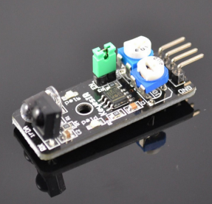
This project will test Infrared obstacle avoidance sensor. When an obstacle is blocks infrared sensor, it will turn on LED in the circuit.
Step 1: connect Infrared obstacle sensor to Arduino as per following graph:
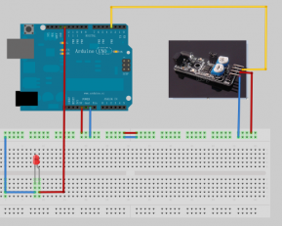
Step 2:Download sample code and load it into Arduino IDE.
Step 3:Run the code and you will see result same as following video.

